MS+ Software

Developer’s Guide
By
Mike Hayden

NOTE: This is sample documentation by Mike Hayden for evaluation. 60 pages only, Table of Contents is thus incomplete.

Table of Contents

Introduction 4
DESIGNING & IMPLEMENTING AN MS+ SERVICE 5
Service Design Phase 5
Configuration Design Phase 12
INSTALLING THE PHONEDIAL SERVICE 13
System Requirements 13
Installing New Installation of PhoneDial 13
How to Upgrade a Previously Installed PhoneDial 13
RUNNING THE PHONEDIAL SERVICE 14
Where is the PhoneDial Service? 14
To Start MS+: 16
To Start the Cell Phone Emulator Package 18
To use the PhoneDial Service 20
CREATING THE PHONEDIAL SERVICE FROM BASIC COMPONENTS 24
Backing up the PhoneDial Service 24
Setting Configuration Files for PhoneDial 26
Assumptions for planning the PhoneDial Service: 26
phonedial Root Folder 27
Config File Templates 27
Config Files Hierarchy 28
How MS+ Loads Config Files 29
More Configuration File Details 29
Configuration file loading 30
Initial Configuration File 30
Including Secondary Configuration Files 30
Configuration File Sets 30
Setting up the phonedial-http.config file 31
First, Think about your Service 31
Examining the phonedial-http.config File 31
Other Considerations 32
config/phonedial/phonedial-http (before) 33
config/phonedial/phonedial-http (after) 34
Setting up the store.config File 35
Copy the store.config template file to your own config/phonedial folder. 35
Find and replace @name with phonedial 36
Find and replace other occurrences of “@” 36
store.config (before) 37
store.config (after) 38
Setting up the service.config File 39
(Optional) Copy the service.config template file to your own config/phonedial folder. 39
Find and replace @name with phonedial 40
service.config (before) 41
service.config (after) 43
Setting up the transport.config File for PhoneDial 45
General Guidelines for setting up Transports 46
Instructions for setting up the http Transport for the PhoneDial Service 48
Set Name of Transport 49
Set Threadpool 49
Set Timeouts 49
Set Service Name 49
Set Log Requests (if any) 50
Set Routable to false 50
Set Request Translator 50
Set Command Processor 50
Set Character Encoding 50
Delete the other Transports 51
transport.config (before) 52
transport.config (after) 58
Setting up the default.config file 60
default.config 60
Setting up the main.config File 60
main.config 60
Setting up the local.config File 60
devel.local.config 60
local.config (modified from devel.local.config) 60
Querymaps and Content Templates 60
Purpose of this Section 60
Note: 60
Authentication Module 60
authenticate+CT.null - Content Template 60
invalid-login+CT.null - Content Template 60
main+CT.null - Content Template 60
authenticate+QM.null.null - Querymap 60
on-transaction-start+Q#CC3.null - Querymap 60
useragent+QM.null.null - Querymap 60
Search Module 60
choose-name+CT.null – Content template 60
location+CT.null– Content Template 60
search+CT.null – Content Template 60
choose-name+QM.null.null – Querymap 60
search+QM.null.null – Querymap 60
Dialer Module 60
dialpad+CT.null.WML Content Template 60
dialpad+QM.null.null Querymap 60
worldwide-phoneno+QM.null.null Querymap 60
channel-attributes 60

Introduction
This manual is for the Service Developer who wants hands-on experience with a real MS+ service. This manual is divided in four sections that will tell you how to do the following:
- How to design a service (the PhoneDial Service will be used as a model)
- How to download and install the PhoneDial Service
- How to run the PhoneDial Service
- How to create the PhoneDial Service from Basic Components

The last section mentioned above (How to create the PhoneDial Service from Basic Components), gives a detailed tour of the following items using the PhoneDial Service:
- Configuration “config” files
- Querymaps (how to query the database)
- Content templates (how to layout the retrieved information for the mobile device)

Using the PhoneDial Service as a model you can study a service that works—and what makes it work.
We will step you through the thought processes, the design considerations, the file organizations, etc., up to the completed service. We provide many figures, tables, and cross-references with page numbers to assist you with your learning.
This is not light reading! We assume you have a working knowledge of Java, XML, HTML and WML. Also, you will need to refer to the Reference Section for details on the MSML tags.
It will take your time and dedicated participation to become an effective MS+ Service Developer. However, your efforts will be rewarded by your ability to use the advanced MS+ software to create your own wireless services tailored to your own situation.

DESIGNING & IMPLEMENTING AN MS+ SERVICE
There are several steps to creating a wireless service with MS+.

Service Design Phase
As an overview, let’s say you want a wireless service that will allow someone to do the following via cell phone:
- log in as authorized user via cell phone
- access the company’s employee directory
- search the employee directory, based on one or more characters of the first name
- display the search results
- select one employee name from the search results
- display the phone number(s) and email address for the selected employee
- select one of the employee’s numbers listed
- dial the number
Here’s what the sequence might look to the cell phone user.
1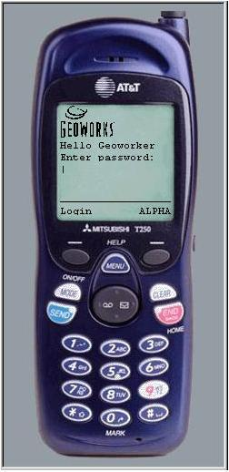 2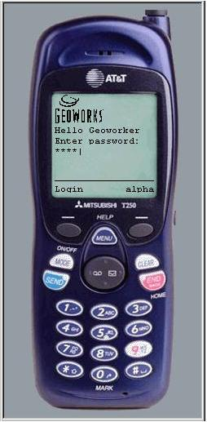 3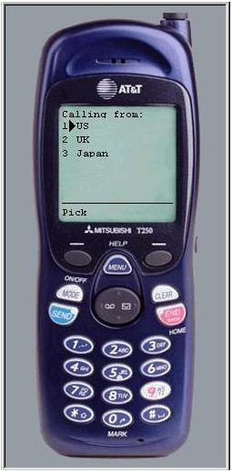
4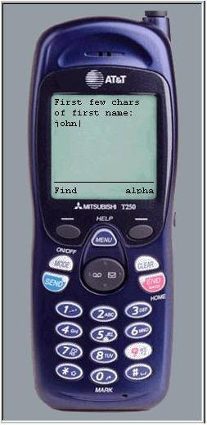 5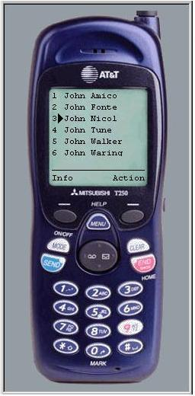 6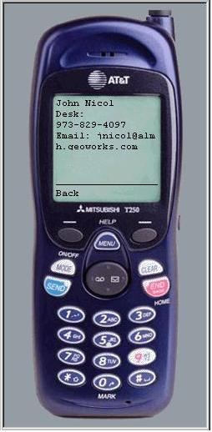
- User accesses the PhoneDial Service; PhoneDial requests password.
- User types in password.
- PhoneDial responds with “Calling from” screen and user selects “US.”
- PhoneDial requests “First few characters of first name”; user types “john.”
- PhoneDial displays matches; user picks #3.
- PhoneDial displays phone numbers and email address.
- User selects desired phone number and the cell phone dials the phone.
To create this service, it is best to plan and diagram how you’re going to set up MS+ to do this. You must think about how you’re going to use the following:
- MS+ configuration files to specify server, service and mobile device details
- MS+ querymaps to access the data
- MS+ content templates to format the data for the cell phone
Assuming you’ve decided to use Oracle database services, let’s examine how you might diagram such a service and plan the use of querymaps and content templates.
First, let’s divide the service into three basic functions (modules), as follows:
- authenticate the user
- search the database and display the results
- dial the number
Here’s how you might diagram these modules.
___Examine Figure 1 that shows the Authentication Module.
- Rounded rectangles represent cell phone screens (created by content templates) and circles represent querymaps.
- The text above the screens and querymaps name the querymap or content template—these names will be covered in detail later.
- The circled numbers represent the basic steps of the communications process, from the user’s request to making the call.

Figure 1. phonedial Authentication Design Module
Step 1
___ Notice that the first screen is the “welcome” screen that requests the user’s password.
___ Notice that we plan for the case where the user keys in an incorrect or illegal password.
If incorrect or illegal, the user must press the cell phone’s BACK button and try again.
___ Notice also, that we’ve planned for the case where the user has timed out.
If so, the user must supply the password again.
___ Assuming the user is authenticated for a successful login, let’s see how you can diagram the Search Module.

___ Examine Figure 2 that shows the search design module.

Figure 2. phonedial Search Design Module
Step 2.
___ Notice that the next screen after successful login asks the user where s/he is calling from.
In this case, user options are US, UK, and Japan, where you have offices. Plus, you know the destination call will go to one of these countries, so you must plan to have MS+ insert the correct country code, if necessary.
Step 3.
___ Notice that the location variable is given to the querymap, which assigns the user’s location as a “session variable.”
MS+ keeps track of many user “session variables” until the user logs out or times out.
Step 4.
___ Next, after the user selects a “calling from” country, the next screen asks for the first few characters of the first name.
One or more characters will work; more characters means fewer responses and less information on the user’s small screen.
Step 5.
___ Notice that in this example, the user types in “John,” and that the variable, startswith, is passed to the querymap. The querymap logic will use sql select to find matching names in your employee database.
Step 6.
___ Notice that the next screen displays employees whose name begins with “John.”
The search “john” would yield John, Johna, Johnnie, Johnny, etc.
The user would then scroll down to select the desired name.
___ Now, let’s see how you might diagram the Dialer Module.

___ Examine Figure 3 that shows the Dialer Design Module.

Figure 3. phonedial Dialer Design Module
Step 7.
___ Notice that the variable, empname, has been passed by the Search Module to the querymap, which:
- selects the employee’s number(s),
- (Step 8.)affixes the destination country’s dial code (if necessary), and
- displays all the numbers, plus the employee’s email address.
Step 9.
Now the user can select one of the numbers and have the number dialed automatically.
(While it would be possible to compose and send an email message from the cell phone, you have decided not to add this feature to this service.)

Configuration Design Phase
The development of a wireless service is a complex process, getting more complex with each passing month. Following are just a few of challenges facing the developer of a mobile information service:
- Different size screens
- Keyboards vs. keypads vs. handwriting vs. voice
- Touch screens vs. jog dials vs. other types of navigation
- Color vs. black and white vs. a few shades of gray
- Graphics or text only
- Large screens, medium screens, or small screens
- Different communication protocols
- Different content languages
- Different implementations of the same content languages
- Custom language extensions
- Different network gateway behaviors and interactions with devices
- Different security regimens
- Different spoken languages
- Different screen navigation schemes
- Verifying database schema consistency
- Database initialization
- Device identification
Geoworks has designed MS+ to accommodate today’s mobile devices and to provide flexibility for tomorrow’s devices.
Unfortunately, MS+ cannot read minds, so the service developer must tell MS+ about the following, among other things:
- the mobile device
- the language it uses
- the transport it uses
- how to translate the device’s input
- where the requested data is located
- how to format the requested data for the device
Thus, the service developer must know how to provide MS+ the information it needs. In general, you accomplish this with querymaps, content templates, variables, and config files.

INSTALLING THE PHONEDIAL SERVICE

System Requirements
- Java Development Kit (JDK) 1.3
- Oracle 8.1 client
- A WAP phone emulator such as OpenWave's UP.SDK 4.1
- Access to a network that can talk to the ala-wis.geoworks.com database

Installing New Installation of PhoneDial
___ Download phonedial zip file.
___ Unzip the phonedial zip file onto your hard drive. For example, unzip it onto C:\; in this case, a successful unzip will yield a “phonedial” directory under C:\.
___ Bring the file “startms.bat” into a text editor (such as notepad) and examine its contents, as follows:
___ Make sure the PATH variable correctly points to the JDK installed on your machine. It should point to a directory named “bin” which contains the executable “java.exe.”
___ Change the line ORACLE_HOME=... to point to your Oracle 8.1 client.

How to Upgrade a Previously Installed PhoneDial
(TBD)

RUNNING THE PHONEDIAL SERVICE
For your convenience, Geoworks has provided a sample service called “PhoneDial” that you can run and experiment with to learn how MS+ works.
This document tells you how to:
- start and run the PhoneDial Service
- develop the PhoneDial Service from basic components
First, you should run the existing PhoneDial Service to see how it works. Then you can explore and experiment with the PhoneDial Service. Full instructions are included herein for both.

Where is the PhoneDial Service?
The PhoneDial Service is a service designed to run under control of MS+. The PhoneDial Service files are separate from the MS+ server files (the same way document files are separate from the word processor files). With that in mind, the PhoneDial Service consists of 3 folders of :
- Querymaps that specify data retrieval, and,
- Content templates that format retrieved data for the phone’s display screen.

___ In Figure 4, notice that the phonedial service consists of 3 sets of querymaps and content templates in 3 folders called: dialer-auth, main, and search-auth.
These 3 folders correspond to the 3 design modules discussed earlier. (Refer back to Figure 1, Figure 2, and Figure 3 starting on page 9.)

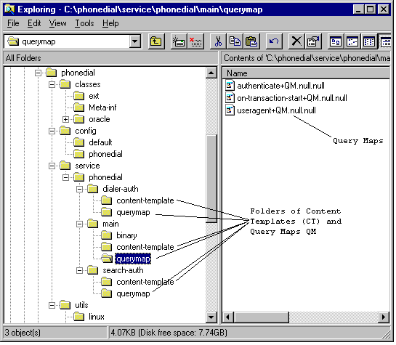

Figure 4. phonedial’s querymaps and content templates

To Start MS+:
___ In the phonedial root folder, double-click startms.bat. (See Figure 5 below.)
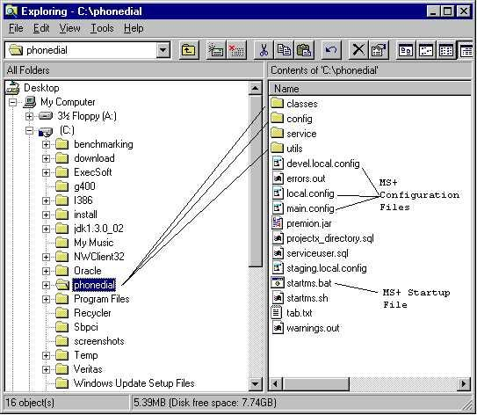

Figure 5. phonedial’s root folder
Double-clicking the .bat (batch) file starts the MS+ Server and brings up the Local Console window as seen in Figure 6 below.
The Local Console is used for debugging during service development. It will be discussed as a separate topic later. (Also, see Figure 7 below for a sample console window showing errors.)
For now, proceed with the next step, which is to start the cell phone emulator, on page 18.

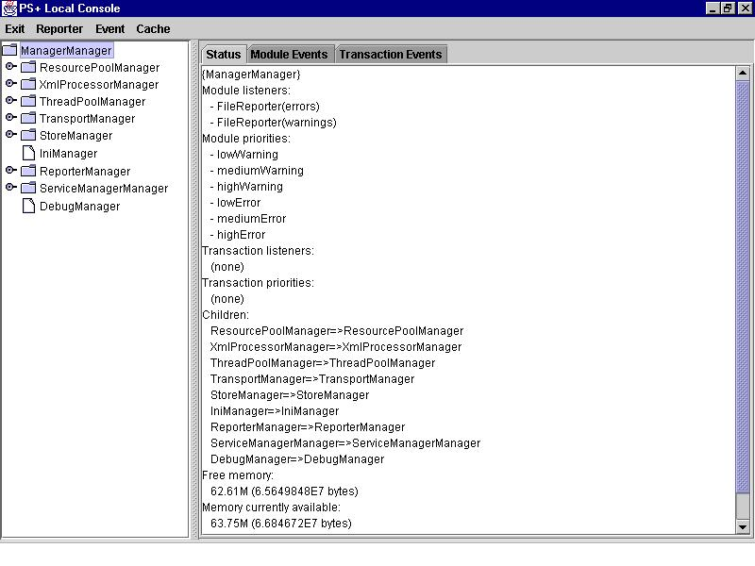

Figure 6 Local Console Window
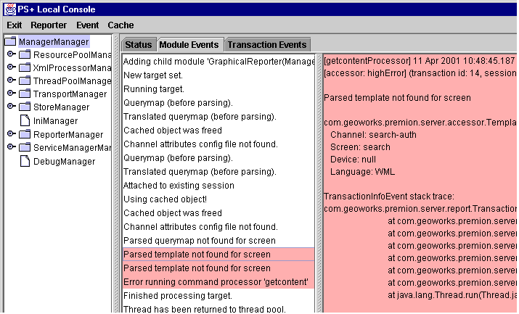

Figure 7. Local Console Window showing Errors

To Start the Cell Phone Emulator Package
Now that the MS+ Server has been started, you need to start the cell phone emulator package, which by the way, can emulate a variety of cell phones.
___ From the Windows Start button go to:
Start/Programs/UP.SDK4.1/UP.Simulator
(See Figure 8.)
This will bring up the phone emulator screen. (See .Figure 9)
___ Point the location to http://localhost/

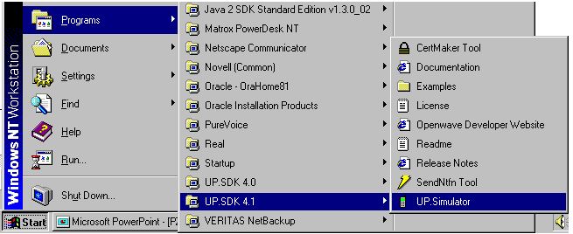

Figure 8. Starting the Cell Phone Emulator

Figure 9. Sample Cell Phone Emulator Display

To use the PhoneDial Service
Once MS+ Server and the PhoneDial Service are running, you’re ready to enter transactions on the (emulated) cell phone.
___ Enter the password as requested by the emulator screen.
___ Press Pick.
This brings up the next emulator screen shown in Figure 10 below, requesting that you select the country you’re calling from.
___ For now, select “US.”
Based on your calling location, the PhoneDial Service will compute how to handle the destination phone number’s area code.
___ Press Pick.
This will bring up the next emulator screen shown in Figure 11 below, requesting that you enter the first few characters of the employee’s first name.

Figure 10. “Calling From” Emulator Display

Figure 11. “First few chars” Emulator Display

___ For now, enter “john” as shown (not case-sensitive here, by design).
___ Press Find.
This will cause MS+ to search the sample database for all employees whose names beginning with “john,” then display the results shown in Figure 12 below.
MS+ (the querymap) sorts the names by first name, then last name.

Figure 12. List of “Johns” Emulator Display

___ Key in “3” or scroll down to the third entry.
___ Press Pick.
This will cause MS+ to display the phone numbers and email address for the third entry in the list, as shown in Figure 13 below.

Figure 13. John’s Phone Numbers and Email Address Emulator Display

___ Scroll down to … yada … yada … yada …

___ You may now experiment with the PhoneDial Service by entering other names, etc., until you understand how it works form a user’s perspective.
The next step, if you’re so inclined, is to find out how it works from a service developer’s point of view. This involves setting up:
- Configuration (“config”) files (to specify system and device configurations),
- Querymaps (to tell MS+ how to access the requested data), and
- Content templates (to tell MS+ how to format the requested data for the requesting device.
Read on.

CREATING THE PHONEDIAL SERVICE FROM BASIC COMPONENTS
First, please copy the working PhoneDial Service to a safe place. Here’s how:

Backing up the PhoneDial Service
___ Select the folder called phonedial, as shown in Figure 14 below.
___ Copy the folder, with all its subfolders, to somewhere you’ll remember. This is your backup!
Now you can explore the PhoneDial Service in its original folders without worrying about recovering PhoneDial in case of errors.

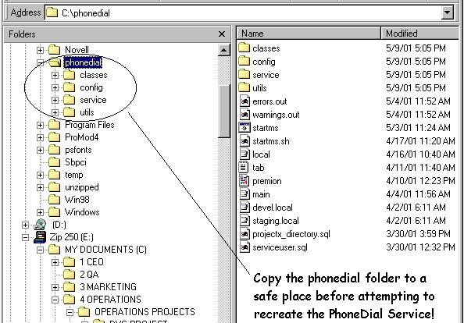

Figure 14. Copy and Save phonedial Folder
___ In Figure 14 above (rt. side) notice the following

For you to recreate the whole PhoneDial Service from basic components requires detailed knowledge of the querymaps, templates, MS+ architecture, configuration files, Java, XML, etc.—plus many more pages in this manual.
Instead of generating PhoneDial from basic components, let’s examine its structure and components along with some explanations, while just discussing what’s needed to build it from basic components.
Lets start with looking at the structure of the PhoneDial folders.
___ Expand the config and service folders so you can see all the subfolders, as shown in Figure 15 below.
NOTE: You will only be exploring and/or modifying the config and service folders; the classes and utils folders will remain the same.

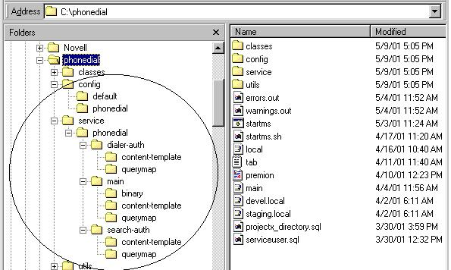

Figure 15. config and service folders and subfolders
___ Notice the files on the right-hand side of Figure 15 above. These are MS+ files, described as follows:
- errors.out errors messages file
- warnings.out warnings messages file
- startms.bat double-click to start MS+
- startms.sh double-click to start Solaris
- local.config template
- tab
- premion MS+ Server software
- main.config template
- staging.local.config template
- projectx_directory.sql
- serviceuser.sql
___ Notice also that there are 3 folders named phonedial.
- The root folder named phonedial.
- A phonedial folder in the config folder.
- A phonedial folder in the service folder.
(explain the convention here?)

Setting Configuration Files for PhoneDial

Assumptions for planning the PhoneDial Service:
For your PhoneDial Service, you’ve decided to use the http transport because your employee phone list is already provided to desktop users using web pages (http). Your goal then, is to setup MS+ to search your company’s employee list for name(s) you specify via cell phone.
Geoworks has provided a sample employee list for your learning experience. However, keep in mind that your electronic employee list could be almost anywhere in any format and you will be able to access it with MS+.
By setting up phonedial-http.config first, you can define and name your lower level config files. Before attempting this, you need some background information. Read on.

phonedial Root Folder

Figure 16 below shows the phonedial root folder and various folders within it.
Notice that the next level of folders under the root folder are the following:
- classes Class files for Java, Oracle, etc.
- config Config file templates
- service Files specific to the phonedial service
- utils Utilities for Linux and Solaris

Figure 16. phonedial Root Folder & 1st Level Sub-Folders

Config File Templates
For your convenience, Geoworks has supplied configuration “config” file templates you can copy and tailor to your own use.
Configuration files are text files that can be read by the Notepad program (or equivalent).
In a way, config files are similar to computer programs, because when you start up MS+, MS+ reads the config files and performs the actions and sets the variables specified by the config file.
Each config file template has comment lines (prefixed by “#”) that explain various concepts and data. You will need to read these comments for full understanding. (See Figure 17 below.)
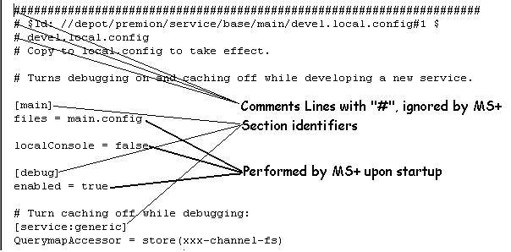

Figure 17. Sample Config File
Any line in a config file that begins with an “#” is ignored by MS+. In some cases, certain commands are “commented out” in order to save them in the file for possible future use.
For ease of identification, lines that will be used by MS+ are printed in larger boldface type than the rest.

Config Files Hierarchy
Notice, in Figure 18, the encircled numbers. These numbers specify the best order to define config files for your service. Therefore, this is the order config files are discussed in this section (i.e. we will start with config/phonedial/phonedial-http.config).

Figure 18. Configuration Files Hierarchy
Later, we’ll describe how to set up the config files for the PhoneDial Service along with a printout of the config files. Table 1 cross-references the various config files with pages where you can find more information.

Table 1. Config Folder Hierarchy
+ config
service.config | Template, see page 39
store.config | Template, see page 35
transport.config | Template, see page 45
+ default
default.config | Default configuration file—  do not change, see page 60
+ phonedial
phonedial-http.config | Config file, see page 48
service.config | Config file, see page 39
store.config | Config file, see page 35
transport.config | Config file, see page 45

How MS+ Loads Config Files
NOTE: MS+ loads the config files according to the hierarchy shown in Figure 18, starting with local.config as follows:
- local.config points to main.config via the statement:
files = main.config)
- main.config points to config/phonedial/phonedialhttp.config via the statement
files = config/phonedial/phonedial-http.config
- config/phonedial/phonedialhttp.config points to the lowest config files via the statement:
files = config/default/default.config, \
config/phonedial/service.config, \
config/phonedial/store.config, \
config/phonedial/transport.config
It’s useful to remember that local.config and main.config are specific to your environment, while the other config files are specific to your service.

More Configuration File Details
MS+ uses text-based configuration files (“*.config”) to initialize the server at start-up time. Currently, you must restart the server to change any configuration files.
You don’t need to modify any configurations files to initially run MS+.

Configuration file loading

Initial Configuration File
MS+ will search for and load a primary configuration file, found in the root server directory. MS+ will first look for a file named “local.config.” If it is not found, MS+ will look for a file named “main.config.” If neither is found, you will be notified of an error.
Service developers will typically create a “local.config” file to override the default configuration.

Including Secondary Configuration Files
Any configuration file can load one or more other configuration files. When a configuration file is loaded, MS+ interprets the “files =” key in the [main] category as a list of other configuration files to load. MS+ loads and processes the files in order. The settings in the last-loaded file take precedence. The settings in one configuration file will always take precedence over any files it includes.
The entries in a files = list may contain relative paths from the server root directory. By convention, all configuration files except the primary configuration files should reside in the config subdirectory.

Configuration File Sets
You can create sets of configuration files to define one or more services. These sets of files should reside in “config/<set-name>”.
A set should have a main configuration file, normally named by the set name (“<set-name>.config”). This file should either:
- directly contain a complete running configuration for the set, or
- include other configuration files to run it.
If a single configuration would be too large, divide the configuration by major configuration files (“transport.config”, “service.config”, “store.config”).
You should prefix categories in set configuration files by the set name, followed by a dash (phonedial-), to avoid naming conflicts. You may configure MS+ to use multiple sets simultaneously. Sets may even reference other sets.
Always configure HTTP transports to use unique port numbers. The configuration file “config/general/transport.config” lists all reserved ports. If you use a new port, you add it to this list.
Developers should use a configuration file set by creating a “local.config” file that directly references the set's main configuration file.

Setting up the phonedial-http.config file
The phonedial-http.config file is based on the main.config file (stored in what folder?).

First, Think about your Service
First, think about your service and how many ways it could be run. This will help you plan and define the service-specific config files for the next level.
Do you want debug reports?
(other questions and considerations)
… yada … yada … yada …

Examining the phonedial-http.config File
___ Look at the phonedial-http.config template on page 33.
This is the template file that came from (where?)
The idea is to start with this config file as a template, delete (or comment out) anything you don’t need, and tailor the remaining lines for PhoneDial.
The lines for possible modification are printed in boldface type.
___ Now, look at the tailored PhoneDial phonedial-http.config file on page 34.
___ Look at these highlighted lines:
[main] A name in brackets, such as [main], names a specific section in the config file; all sections must have names within brackets.
files = Here, you specify the paths to your files for default.config, service.config, store.config, and transport.config
moduleReporters = Here, you set up module reporters, that is, you specify the types of errors you want reported to the Console (or to a file) for debugging purposes. You can change the line later—but, if you comment it out, the default.config will override.
transports = Here, you specify the transports you will be using. For the PhoneDial Service, we only use one transport (http), so only one is listed. Note that “transports = “ refers to transports, not to the config file of the same name, which we will define in transport.config at the next level.
___ Read the # comment lines in the phonedial-http.config file for more information.

Other Considerations
NOTE 1: While PhoneDial is a simple service with just one way to run (http), under phonedial you could have another service, say, phonedial-event.config. (See Figure 19 below). In this case, you need to plan for that service as well.
NOTE 2: Some developers use main.config as one file and would include phonedial-http.config within main.config. However, this presents obstacles to adding new services. Therefore, it is best to have phonedial-http.config as a file under main.config as shown in the hierarchy diagram.
Then, to add a service, simply add it, then make another files = entry into main.config.

Figure 19. Configuration Files Hierarchy, with Possible Added Service

config/phonedial/phonedial-http (before)
(Where does this template file come from?)

config/phonedial/phonedial-http (after)
###############################################################################
# $Id: //depot/premion/service/base/main/main.config#1 $
# main.config

# Sets up the production environment. May be overridden by local.config settings.

[main]

files = config/default/default.config, \
config/phonedial/service.config, \
config/phonedial/store.config, \
config/phonedial/transport.config

# Set module reporters for top level manager. We dispense with some or all of these:
moduleReporters = warnings, errors

# Choose transports to activate from this list:
transports = phonedial-http

# It may be necessary to adjust the tags recognised in QMs and CTs.
# The default lists are in default.config.

# If the XML and XPATH tags are required (as for ual-japan):
#[xmlProcessor:querymapProcessor]
#tags = ...

#[xmlProcessor:reportWriter]
#tags = ...

Setting up the store.config File
In this section, you will set your host computer, database, username, and password. NOTE: Any settings in this file can be superceded by the settings in local.config.
Notice in Figure 20 below, the location of the config file (circled) you will use as a template for PhoneDial’s store.config files.

Figure 20. Copy and tailor store.config, place in phonedial folder

Copy the store.config template file to your own config/phonedial folder.
___ Copy the store.config template from the config folder and place it into the phonedial folder, as shown in Figure 20 above.
You are now ready to modify the copied file.
___ See page 37 for a printout of the template config file.
This shows how the store.config file appears before you make the changes that follow.
___ Open the copied file in your text editor and make the changes specified in the following steps.

Find and replace @name with phonedial
___ Using your search and replace feature, replace all occurrences of @name with phonedial.
This will replace the following entries in this file:
[store:@name-db]
[store:@name-fs]
path = service/@name

Find and replace other occurrences of “@”
In the following steps, you will setup the names for your host computer, database, username, and password.
___ Find @hostname and replace with the name of your host computer.
In the example shown, the host name is ala-wis.
___ Find @dbname and replace with the name of your database.
In the example shown, the database name is perseus.
___ Find @username and replace with your username.
In the example shown, the username is devwarren.
___ Find @passwd and replace with your password.
In the example shown, the username is devwarren.
___ Save the store.config file.
___ Verify that your new store.config matches the printout on page 38.
The next step is to setup the service.config file; go to page 39.

store.config (before)
###############################################################################
# $Id: //depot/premion/service/base/main/config/store.config#1 $
# Stores
# 230301 mdm Created

[store:@name-db]
type = com.geoworks.premion.server.store.DBStore
driverClass = oracle.jdbc.driver.OracleDriver
url=jdbc:oracle:thin:@hostname:@1521:@dbname
loginName=@username
password=@passwd
# For MySQL databases:
#[store:@name-db]
#type = com.geoworks.premion.server.store.DBStore
#driverClass = org.gjt.mm.mysql.Driver
#url=jdbc:mysql://host:port/@dbname?user=@user&password=@pass&autoReconnect=true&maxReconnects=3
#loginName=
#password=

[store:@name-fs]
type = com.geoworks.premion.server.store.FileStore

# Convention is a @name subdirectory under the "service" directory. Some
# services have just path=service and put "main", "error", etc. in "service".
path = service/@name

# If you want Shift-JIS encoding
#encoding = SJIS

store.config (after)
###############################################################################
# $Id: //depot/premion/service/base/main/config/store.config#1 $
# Stores
# 230301 mdm Created

[store:phonedial-db]
type = com.geoworks.premion.server.store.DBStore
driverClass = oracle.jdbc.driver.OracleDriver
url=jdbc:oracle:thin:ala-wis:1521:perseus
loginName=devwarren
password=devwarren
# For MySQL databases:
#[store:@name-db]
#type = com.geoworks.premion.server.store.DBStore
#driverClass = org.gjt.mm.mysql.Driver
#url=jdbc:mysql://host:port/@dbname?user=@user&password=@pass&autoReconnect=true&maxReconnects=3
#loginName=
#password=

[store:phonedial-fs]
type = com.geoworks.premion.server.store.FileStore

# Convention is a @name subdirectory under the "service" directory. Some
# services have just path=service and put "main", "error", etc. in "service".
path = service/phonedial

# If you want Shift-JIS encoding
#encoding = SJIS

Setting up the service.config File
Notice in Figure 21 below, the location of the service config file (circled) you will use as a template for PhoneDial’s service.config files.

Figure 21. Copy and tailor service.config, place in phonedial folder

In the following steps, you will be changing certain information in the service.config file supplied by Geoworks.

(Optional) Copy the service.config template file to your own config/phonedial folder.
The following steps explain what you would do if you were starting from basic components with a new template file.
___ Copy the service.config template from the config folder and place it into the phonedial folder, as shown in Figure 21 above.
You are now ready to modify the copied file.
___ See page 41 for a printout of the template config file.
This shows how the service.config file appears before you make the changes that follow.
___ Open the copied file in your text editor and make the changes specified in the following steps.
___ To find out what the various highlighted lines mean, study the # comment lines in the printout.
Again, the following steps explain what you would do if you were starting from basic components with the template file.

Find and replace @name with phonedial
___ Notice the following statement at the beginning of the file:
# Change the places flagged with an @
___ Also, notice that there are several “@name” entries in the service.config file. For your information:
- @name-db specifies a database
- @name-fs specifies a file system
The contents and meaning of the service.config file are too complicated to cover here. For more information, read the comments and refer to the technical documentation.
The only thing you need to do with this file is “Change the places that flagged with an @”. For example, you will change
[service:@name] to [service:phonedial], etc.
___ Using your search and replace feature, replace all occurrences of
@name with phonedial.
___ Next, find the following line:
BinaryAccessor = store(ual-japan-channel-fs), \
Com/geoworks.premion…(etc)
___ Delete this line and all its following lines all the way to the end of the service.config file.
___ Save the service.config file.
___ Verify that your new service.config matches the printout on page 43.

service.config (before)
# service.config
# $Id:$
# Prototype configuration file for a single service.
# Change the places flagged with an @
#
# 230301 mdm Remove some explicit service names and replace by @name.
# Squash all database store references to one, since this is commonest.
# Add QM/CT/Binary Cache accessors by default (can be disabled in #local.config).

[service:@name]
#
# This section defines the parameters of the ? service.
#

#
# Define the different accessors that are associated with the service.
# Usually this is a fairly standard set of accessors, but one might define
# new accessors for new data types. Each element here has a corresponding
# key down below that defines the associated class and/or store against
# which the accessor should work. For an accessor defined as store(name),
# look for a category [store:name] in the configuration to determine what
# the source of the data is.
#
accessors = \
BinaryAccessor, \
QuerymapAccessor, QuerymapParsedAccessor, \
TemplateAccessor, TemplateParsedAccessor, \
ChannelAttributesAccessor, \
UserVariablesVarContextAccessor, \
UserInfoVarContextAccessor, UserValidationAccessor, \
LangmapVarContextAccessor, \
RequestLogAccessor, SessionLogAccessor, DispatchLogAccessor, \
SQLTableAccessor, EventAccessor, FileAccessor

#
# Define the actual accessors for each of the data types listed in the
# accessors key, above.
# Each entry is one or more elements, separated by commas. Most will have
# at least a store(store-name) at the start, which means data should be
# fetched from that data store. Other entries are classes that will either
# transform the data, or cache it, or be flexible in how it looks for it.
#

#
# User-related accessors. These usually come from the same store.
#
UserVariablesVarContextAccessor = store(@name-db)
UserInfoVarContextAccessor = store(@name-db)
UserValidationAccessor = store(@name-db)

#
# Language map variable accessors
#
LangmapVarContextAccessor = store(@name-db), \
com.geoworks.premion.server.accessor.stream.cache.LangmapVarContextCacheAccessor

# Channel object accessors. These typically are set up as a sequence of
# accessors, allowing data objects to be transformed and/or cached along
# the way. The current service is set up to *not* cache templates or querymaps,
# allowing them to be changed on the filesystem and take immediate effect. If
# one wanted to cache the results of parsing these files, one would include
# accessor.stream.cache.QuerymapParsedCacheAccessor at the end of the
# list for QuerymapParsedAccessor, or
# accessor.stream.cache.TemplateParsedCacheAccessor at the end of the list
# for TemplateParsedAccessor.
#

# 230301: + *.*CacheAccessor:
BinaryAccessor = store(@name-fs), \
com.geoworks.premion.server.accessor.stream.translate.FindBinaryAccessor, \
com.geoworks.premion.server.accessor.stream.cache.BinaryCacheAccessor

QuerymapAccessor = store(@name-fs)
QuerymapParsedAccessor = com.geoworks.premion.server.accessor.stream.transform.QuerymapParsedTransformAccessor, \
com.geoworks.premion.server.accessor.stream.translate.FindQuerymapParsedAccessor, \
com.geoworks.premion.server.accessor.stream.cache.QuerymapParsedCacheAccessor

TemplateAccessor = store(@name-fs)
TemplateParsedAccessor = com.geoworks.premion.server.accessor.stream.transform.TemplateParsedTransformAccessor, \
com.geoworks.premion.server.accessor.stream.translate.FindTemplateParsedAccessor, \
com.geoworks.premion.server.accessor.stream.cache.TemplateParsedCacheAccessor

ChannelAttributesAccessor = store(@name-fs), \
com.geoworks.premion.server.accessor.stream.cache.ChannelAttributesCacheAccessor

#
# Log accessors. RequestLog holds information for each request. SessionLog
# records session creation and destruction. DispatchLog records data sent
# to clients.
#
RequestLogAccessor = store(@name-db)
SessionLogAccessor = store(@name-db)
DispatchLogAccessor = store(@name-db)

#
# Content accessors. SQLTableAccessor determines in what store(s) the
# SQL tag is allowed to look. If you want SQL to be able to look in more
# than one place (as determined by the "store" attribute of the tag), you
# must list each store here, as "store(store1, store2, store3)"
#
SQLTableAccessor = store(@name-db)
#
# EventAccessor tells any event service you're using where to find its
# events, as well as where the SETEVENT and CANCELEVENT tags should operate.
#
EventAccessor = store(@name-db)
#
# FileAccessor tells the FILEGET tag where it can look for files.
#
FileAccessor = store(@name-fs)

BinaryAccessor = store(ual-japan-channel-fs), \
com.geoworks.premion.server.accessor.stream.translate.FindBinaryAccessor, \
com.geoworks.premion.server.accessor.stream.cache.BinaryCacheAccessor

QuerymapAccessor = store(ual-japan-channel-fs)
QuerymapParsedAccessor = \
com.geoworks.premion.server.accessor.stream.transform.QuerymapParsedTransformAccessor, \
com.geoworks.premion.server.accessor.stream.translate.FindQuerymapParsedAccessor, \
com.geoworks.premion.server.accessor.stream.cache.QuerymapParsedCacheAccessor

TemplateAccessor = store(ual-japan-channel-fs)
TemplateParsedAccessor = \
com.geoworks.premion.server.accessor.stream.transform.TemplateParsedTransformAccessor, \
com.geoworks.premion.server.accessor.stream.translate.FindTemplateParsedAccessor, \
com.geoworks.premion.server.accessor.stream.cache.TemplateParsedCacheAccessor

service.config (after)
# service.config
# $Id:$
# Prototype configuration file for a single service.
# Change the places flagged with an @
#
# 230301 mdm Remove some explicit service names and replace by phonedial.
# Squash all database store references to one, since this is commonest.
# Add QM/CT/Binary Cache accessors by default (can be disabled in #local.config).

[service:phonedial]
#
# This section defines the parameters of the ? service.
#

#
# Define the different accessors that are associated with the service.
# Usually this is a fairly standard set of accessors, but one might define
# new accessors for new data types. Each element here has a corresponding
# key down below that defines the associated class and/or store against
# which the accessor should work. For an accessor defined as store(name),
# look for a category [store:name] in the configuration to determine what
# the source of the data is.
#
accessors = \
BinaryAccessor, \
QuerymapAccessor, QuerymapParsedAccessor, \
TemplateAccessor, TemplateParsedAccessor, \
ChannelAttributesAccessor, \
UserVariablesVarContextAccessor, \
UserInfoVarContextAccessor, UserValidationAccessor, \
LangmapVarContextAccessor, \
RequestLogAccessor, SessionLogAccessor, DispatchLogAccessor, \
SQLTableAccessor, EventAccessor, FileAccessor

#
# Define the actual accessors for each of the data types listed in the
# accessors key, above.
# Each entry is one or more elements, separated by commas. Most will have
# at least a store(store-name) at the start, which means data should be
# fetched from that data store. Other entries are classes that will either
# transform the data, or cache it, or be flexible in how it looks for it.
#

#
# User-related accessors. These usually come from the same store.
#
UserVariablesVarContextAccessor = store(phonedial-db)
UserInfoVarContextAccessor = store(phonedial-db)
UserValidationAccessor = store(phonedial-db)

#
# Language map variable accessors
#
LangmapVarContextAccessor = store(phonedial-db), \
com.geoworks.premion.server.accessor.stream.cache.LangmapVarContextCacheAccessor

# Channel object accessors. These typically are set up as a sequence of
# accessors, allowing data objects to be transformed and/or cached along
# the way. The current service is set up to *not* cache templates or querymaps,
# allowing them to be changed on the filesystem and take immediate effect. If
# one wanted to cache the results of parsing these files, one would include
# accessor.stream.cache.QuerymapParsedCacheAccessor at the end of the
# list for QuerymapParsedAccessor, or
# accessor.stream.cache.TemplateParsedCacheAccessor at the end of the list
# for TemplateParsedAccessor.
#

# 230301: + *.*CacheAccessor:
BinaryAccessor = store(phonedial-fs), \
com.geoworks.premion.server.accessor.stream.translate.FindBinaryAccessor, \
com.geoworks.premion.server.accessor.stream.cache.BinaryCacheAccessor

QuerymapAccessor = store(phonedial-fs)
QuerymapParsedAccessor = com.geoworks.premion.server.accessor.stream.transform.QuerymapParsedTransformAccessor, \
com.geoworks.premion.server.accessor.stream.translate.FindQuerymapParsedAccessor, \
com.geoworks.premion.server.accessor.stream.cache.QuerymapParsedCacheAccessor

TemplateAccessor = store(phonedial-fs)
TemplateParsedAccessor = com.geoworks.premion.server.accessor.stream.transform.TemplateParsedTransformAccessor, \
com.geoworks.premion.server.accessor.stream.translate.FindTemplateParsedAccessor, \
com.geoworks.premion.server.accessor.stream.cache.TemplateParsedCacheAccessor

ChannelAttributesAccessor = store(phonedial-fs), \
com.geoworks.premion.server.accessor.stream.cache.ChannelAttributesCacheAccessor

#
# Log accessors. RequestLog holds information for each request. SessionLog
# records session creation and destruction. DispatchLog records data sent
# to clients.
#
RequestLogAccessor = store(phonedial-db)
SessionLogAccessor = store(phonedial-db)
DispatchLogAccessor = store(phonedial-db)

#
# Content accessors. SQLTableAccessor determines in what store(s) the
# SQL tag is allowed to look. If you want SQL to be able to look in more
# than one place (as determined by the "store" attribute of the tag), you
# must list each store here, as "store(store1, store2, store3)"
#
SQLTableAccessor = store(phonedial-db)
#
# EventAccessor tells any event service you're using where to find its
# events, as well as where the SETEVENT and CANCELEVENT tags should operate.
#
EventAccessor = store(phonedial-db)
#
# FileAccessor tells the FILEGET tag where it can look for files.
#
FileAccessor = store(phonedial-fs)

Setting up the transport.config File for PhoneDial
Notice in Figure 22 below the transport.config file (circled) you will use as a template for PhoneDial’s transport.config file.

Figure 22. Copy and tailor transport.config, place in phonedial folder

General Guidelines for setting up Transports
To review, the Transport Layer software, detects incoming requests, formats them, sends them to the Request Processing Software (RP), and then waits for the RP to answer. See Figure 23 below.

Figure 23. Request Processing Overview
Here’s a useful analogy for understanding MS+. When you tell your computer to print something, the computer must know certain information about the printer and its connection, such as make & model, what port it’s on, transfer speeds, print format, whether direct or LAN connected, which driver software to use, etc.
Similarly, for MS+ to respond properly, MS+ must know certain information about the requesting device including:
- the mobile device
- the language it uses
- the transport it uses
- how to translate the device’s input
- where the requested data is located
- how to format the requested data for the device
You, the service developer, must give MS+ the information it needs so it can respond correctly.
MS+ comes with many transports and other pieces of software that must be tailored to a given situation. Table 2 below shows the minimum requirements necessary kinds of services. (An “X” in the column means the item is required.)
For example, the table says that all transports must specify the following:
- threadPool the thread pool coordinates and schedules internal activities
- listener the name of the software that listens for communication and initiates appropriate action
- service the name of the service software
- request translators the name of the request translator software

Table 2 Transport Configuration Table
(this table needs confirmation)
 | email | sample  email | signup  email | direct  email | upinews  email | sms | sms  display | http | secure  http | events
threadPool | X | X | X | X | X | X | X | X | X | X
listener | X | X | X | X | X | X |  | X | X | X
service | X | X | X | X | X | X | X | X | X | X
port |  |  |  | X |  | X |  | X | X
request translators | X |  | X |  |  | X |  | X | X | X
secure |  |  |  |  |  |  |  |  | true
defaultScheme |  |  |  |  |  |  |  |  | https
loginType |  |  | X |  |  | anonymous
dispatcher | X | X | X |  |  |  | X
dispatcherServer | X
listenerServer | X
replyDomain | X
commandProcessors | X | X |  | X | X |  | X
deleteMail | true
server |  | X | X |  | X
user | X | X | X |  | X
password | X | X | X |  | X
usePassword |  |  |  |  |  | X
replyDomain |  |  | X

As you can see from the table, certain applications require other items to be set. For the PhoneDial Service, using http, while commandProcessors is optional, you will need to specify commandProcessors in order to do the processing required for the PhoneDial Service.
The following instructions assume you are starting from basic components from a transport.config template. For expediency in learning, you may wish to simply study the instructions plus the before / after transport.config listings on pages 52 and 58 respectively.

Instructions for setting up the http Transport for the PhoneDial Service
To set up the transport.config file, we’re going to start with a dummy transport.config file and tailor it to suit the PhoneDial Service. The dummy transport.config file contains dummy transports, separated by lines of #####’s, for the following transports: (See Table 3.)

Table 3. Transports Included in the transport.config Template
[transport:@name-http] | Used for connecting to http servers
[transport:@name-gsm-at-sms] | Used for SMS messaging
[transport:@name-sms-test] | Used to test SMS messaging
[transport:@name-sms-gw-test] | Used to test SMS messaging
[transport:@name-events] | Used to set up internal events
[transport:@name-email] | Used for email
The characters “@name-” indicate where you are to insert an actual transport name.
For the PhoneDial Service, we will use only the http transport; the others will be deleted from the transport.config file.

Set Name of Transport
___ Copy the transport.config template file from the config folder to the phonedial folder as shown in Figure 22, page 45 above.
This is the transport.config file you will modify to create the file for your new service.
___ Open the transport.config file in a text processor, such as Notepad.
___ Change [transport:@name-http] to [transport:phonedial-http]

Set Threadpool
___ Set threadpool = main

Set Timeouts
___ Set timeout = 150
This says wait a maximum of 150 seconds for data to return, otherwise it’s been busy for too long.
___ Set sessionTimeoutPeriod = 15
This says if the user doesn’t make a request within 15 minutes, log out the user; idle for too long.

Set Service Name
___ Change service = @service to service = phoneDial
The service name must match the service object in service.config file. This associates the transport with the phoneDial service.

Set Log Requests (if any)
___ Set logRawRequest and logDispatchBody to true.
Normally, logRawRequest and logDispatchBody are set true, which causes MS+ to log request and dispatch records to a database for the purpose of checkout and debugging. Thus, not used in normal situations because it can use up much database space. If set false, no data is stored.
logRawRequest and logDispatchBody are defined in service.config where you define what data stores are used (RequestLogAccessor and DispatchLogAccessor).

Set Routable to false
___ Set routable = false
Normally, routable is set to false unless your server is operating in a server farm (multiple machines) where user requests can be “routed” to any of several machines. If routing is used, it is transparent to the user.

Set Request Translator
___ Enter the following for the Request Translator:
com.geoworks.premion.server.transport.http.HttpToCgiExtendedTranslator
The Request Translator determines how the request is translated. The Request Translator and Command Processor (next) are fixed for http.

Set Command Processor
The Command Processors are fixed for http.
___ Enter the following for the Command Translator.
com.geoworks.premion.server.command.getcontentProcessor
com.geoworks.premion.server.command.getbinaryProcessor
com.geoworks.premion.server.command.logoutProcessor
com.geoworks.premion.server.command.runProcessor

Set Character Encoding
For the PhoneDial Service, there is no need to specify any special character encodings. However:
___ Notice the line that begins with:
# Uncomment for Shift-JIS.
This is the area of this config file that you would modify to set up the handling of Japanese or other types of characters.

Delete the other Transports
For the PhoneDial Service, there is no need for the other transports. Therefore:
___ Select and delete the rest of the transport.config file, starting with:
#################…
[transport:@name-gsm-at-sms]
.
.
.
(all the way to the end of the text file)
___ (Alternatively, you could comment out (#) all the unneeded transport lines.)
___ Save the transport.config file.

transport.config (before)
###############################################################################
# $Id: //depot/premion/service/base/main/config/transport.config#1 $
# Transports
# 1) HTTP
# 2) GSM-AT SMS (Phone On the Wall)
# 3) SMS tester
# 4) SMS (gateway) emulator
# 5) Events
# 6) Email
# Few services will require them all, so comment out the unused ones.
# Change values flagged with @

#
# Basic HTTP transport configuration. Change the places flagged with an @
# Was formerly "http.config".

[transport:@name-http]
#
# flight-http is the WWW access to the service.
#

# Define the class that will listen for requests on this transport.
listener = com.geoworks.premion.server.transport.http.httpstandard.HttpStandardListener

# Tell it to use port ?. Default HTTP port is 80.
port = @port

# Define which pool of threads should process incoming requests. threadpool:main
# is defined in default.config. You may want to redefine it in your main.config
# file to tweak performance.
threadPool = main

#
# Number of seconds we will wait for data from the client before declaring
# the request dead, when reading the HTTP request from the socket.
#
timeout = 150

# loginType controls which rows in the user_validation table are used to
# authenticate users. it is matched against the login_type column.
loginType = normal

# number of minutes of idle time before a session is destroyed
sessionTimeoutPeriod = 15

# with what service is this transport associated?
service = @service

# these flags control additional logging. where the data are logged depends
# on the store you specify for RequestLogAccessor and DispatchLogAccessor
# in the configuration of the associated service.
logRawRequest = false
logDispatchBody = false

# the routable flag controls whether this server is operating in a server
# farm, requiring user-associated requests to be routed to the server on
# which the user has an active session. This server is standalone, so
# we set routable to false.
routable = false

# define the classes used to translate a request into a generic request. for
# this service, we just use one class to convert from an HTTP request
requestTranslators = com.geoworks.premion.server.transport.http.HttpToCgiExtendedTranslator

# define the different command processors that are accessible on this transport
commandProcessors = com.geoworks.premion.server.command.getcontentProcessor, \
com.geoworks.premion.server.command.getbinaryProcessor, \
com.geoworks.premion.server.command.logoutProcessor, \
com.geoworks.premion.server.command.runProcessor

# Uncomment for Shift-JIS. Other possible input encodings: EUC-JP, UTF8, JISAutoDetect
#inputEncoding = SJIS

# Other possible output encodings: EUC-JP, UTF8
#outputEncoding = SJIS

###############################################################################
[transport:@name-gsm-at-sms]
listener = com.geoworks.premion.server.transport.sms.gsmat.GsmAtListener
dispatcher = com.geoworks.premion.server.transport.sms.gsmat.GsmAtDispatcher

# Nokia Data Suite will create a pseudo port COM3
port = 3

threadPool = main
sessionTimeoutPeriod = 1
loginType=phone
service = @service
requestTranslators = com.geoworks.premion.server.transport.sms.SmsToTextKeywordTranslator
commandProcessors = com.geoworks.premion.server.command.getcontentProcessor, \
com.geoworks.premion.server.command.runProcessor

logRawRequest = true

# Do outgoing numbers require a "+" prefix? Most UK networks seem to (or they don't object).
numbersRequirePlusPrefix = true

# Necessary for 3.2 server:
gsmAtGatewayResource = com.geoworks.premion.server.transport.sms.gsmat.GsmAtGatewayPhone

###############################################################################
# SMS Test Display: one-line "Enter Message:" field, some grey background.
# Prettier than the @name-sms-gw-test transport. Only for emulating Phone On the Wall.
[transport:@name-sms-test]
listener = com.geoworks.premion.server.transport.sms.testdisplay.SmsTestListener
dispatcher = com.geoworks.premion.server.transport.sms.testdisplay.SmsTestDispatcher
loginType = phone
threadPool = main
service = @service
requestTranslators = com.geoworks.premion.server.transport.sms.SmsToTextKeywordTranslator
commandProcessors = com.geoworks.premion.server.command.getcontentProcessor, \
com.geoworks.premion.server.command.runProcessor

###############################################################################
# SMS (Gateway) Emulator: multi-line "Enter Message:" textarea, all-white background.
# Inputs the nasty "FORWARD" SMS but is better (safer?) for emulating an SMS gateway.
[transport:@name-sms-gw-test]
loginType=phone
listener = com.geoworks.premion.server.transport.sms.gateway.SMSListener
dispatcher = com.geoworks.premion.server.transport.sms.gateway.SMSDispatcher
threadPool = main
#sessionTimeoutPeriod = 1
service = @service
requestTranslators = com.geoworks.premion.server.transport.sms.SmsToTextKeywordTranslator
commandProcessors = com.geoworks.premion.server.command.getcontentProcessor, \
com.geoworks.premion.server.command.runProcessor
smsGatewayConfigFile = config/SMSGateway.config
gateway = com.geoworks.premion.server.transport.sms.gateway.test.TestSMSGateway

###############################################################################
[transport:@name-events]
listener = com.geoworks.premion.server.transport.event.EventListener
consumerCount = 10
threadPool = main
service = canned
requestTranslators = com.geoworks.premion.server.transport.event.EventToCgiExtendedTranslator
commandProcessors = com.geoworks.premion.server.command.runProcessor
sessionTimeoutPeriod = 10

###############################################################################
[transport:@name-email]

listener = com.geoworks.premion.server.transport.email.pop3.Pop3Listener
listenerServer = ukmh.geoworks.co.uk
user = @username
password = @passwd
# Every 10 secs:
pollRate = 10
# If you don't delete mail, Pop3Listener will keep processing the messages it has already seen.
deleteMail = true
# This is required for authenticating email users on an email transport.
loginType = anonymous
checkPassword = false

# If this works for you, leave it be. However, the advent of Groupwoes may have affected it.
dispatcher = com.geoworks.premion.server.transport.email.smtp.SmtpDispatcher
dispatcherServer = ukmh.geoworks.co.uk
replyDomain = geoworks.co.uk

threadPool = main
sessionTimeoutPeriod = 1
service = generic
requestTranslators = com.geoworks.premion.server.transport.email.EmailToTextKeywordTranslator
commandProcessors = com.geoworks.premion.server.command.runProcessor
logRawRequest = true

###############################################################################
# $Id: //depot/premion/service/base/main/config/transport.config#1 $
# Transports
# 1) HTTP
# 2) GSM-AT SMS (Phone On the Wall)
# 3) SMS tester
# 4) SMS (gateway) emulator
# 5) Events
# 6) Email
# Few services will require them all, so comment out the unused ones.
# Change values flagged with @

#
# Basic HTTP transport configuration. Change the places flagged with an @
# Was formerly "http.config".

[transport:@name-http]
#
# flight-http is the WWW access to the service.
#

# Define the class that will listen for requests on this transport.
listener = com.geoworks.premion.server.transport.http.httpstandard.HttpStandardListener

# Tell it to use port ?. Default HTTP port is 80.
port = @port

# Define which pool of threads should process incoming requests. threadpool:main
# is defined in default.config. You may want to redefine it in your main.config
# file to tweak performance.
threadPool = main

#
# Number of seconds we will wait for data from the client before declaring
# the request dead, when reading the HTTP request from the socket.
#
timeout = 150

# loginType controls which rows in the user_validation table are used to
# authenticate users. it is matched against the login_type column.
loginType = normal

# number of minutes of idle time before a session is destroyed
sessionTimeoutPeriod = 15

# with what service is this transport associated?
service = @service

# these flags control additional logging. where the data are logged depends
# on the store you specify for RequestLogAccessor and DispatchLogAccessor
# in the configuration of the associated service.
logRawRequest = false
logDispatchBody = false

# the routable flag controls whether this server is operating in a server
# farm, requiring user-associated requests to be routed to the server on
# which the user has an active session. This server is standalone, so
# we set routable to false.
routable = false

# define the classes used to translate a request into a generic request. for
# this service, we just use one class to convert from an HTTP request
requestTranslators = com.geoworks.premion.server.transport.http.HttpToCgiExtendedTranslator

# define the different command processors that are accessible on this transport
commandProcessors = com.geoworks.premion.server.command.getcontentProcessor, \
com.geoworks.premion.server.command.getbinaryProcessor, \
com.geoworks.premion.server.command.logoutProcessor, \
com.geoworks.premion.server.command.runProcessor

# Uncomment for Shift-JIS. Other possible input encodings: EUC-JP, UTF8, JISAutoDetect
#inputEncoding = SJIS

# Other possible output encodings: EUC-JP, UTF8
#outputEncoding = SJIS

###############################################################################
[transport:@name-gsm-at-sms]
listener = com.geoworks.premion.server.transport.sms.gsmat.GsmAtListener
dispatcher = com.geoworks.premion.server.transport.sms.gsmat.GsmAtDispatcher

# Nokia Data Suite will create a pseudo port COM3
port = 3

threadPool = main
sessionTimeoutPeriod = 1
loginType=phone
service = @service
requestTranslators = com.geoworks.premion.server.transport.sms.SmsToTextKeywordTranslator
commandProcessors = com.geoworks.premion.server.command.getcontentProcessor, \
com.geoworks.premion.server.command.runProcessor

logRawRequest = true

# Do outgoing numbers require a "+" prefix? Most UK networks seem to (or they don't object).
numbersRequirePlusPrefix = true

# Necessary for 3.2 server:
gsmAtGatewayResource = com.geoworks.premion.server.transport.sms.gsmat.GsmAtGatewayPhone

###############################################################################
# SMS Test Display: one-line "Enter Message:" field, some grey background.
# Prettier than the @name-sms-gw-test transport. Only for emulating Phone On the Wall.
[transport:@name-sms-test]
listener = com.geoworks.premion.server.transport.sms.testdisplay.SmsTestListener
dispatcher = com.geoworks.premion.server.transport.sms.testdisplay.SmsTestDispatcher
loginType = phone
threadPool = main
service = @service
requestTranslators = com.geoworks.premion.server.transport.sms.SmsToTextKeywordTranslator
commandProcessors = com.geoworks.premion.server.command.getcontentProcessor, \
com.geoworks.premion.server.command.runProcessor

###############################################################################
# SMS (Gateway) Emulator: multi-line "Enter Message:" textarea, all-white background.
# Inputs the nasty "FORWARD" SMS but is better (safer?) for emulating an SMS gateway.
[transport:@name-sms-gw-test]
loginType=phone
listener = com.geoworks.premion.server.transport.sms.gateway.SMSListener
dispatcher = com.geoworks.premion.server.transport.sms.gateway.SMSDispatcher
threadPool = main
#sessionTimeoutPeriod = 1
service = @service
requestTranslators = com.geoworks.premion.server.transport.sms.SmsToTextKeywordTranslator
commandProcessors = com.geoworks.premion.server.command.getcontentProcessor, \
com.geoworks.premion.server.command.runProcessor
smsGatewayConfigFile = config/SMSGateway.config
gateway = com.geoworks.premion.server.transport.sms.gateway.test.TestSMSGateway

###############################################################################
[transport:@name-events]
listener = com.geoworks.premion.server.transport.event.EventListener
consumerCount = 10
threadPool = main
service = canned
requestTranslators = com.geoworks.premion.server.transport.event.EventToCgiExtendedTranslator
commandProcessors = com.geoworks.premion.server.command.runProcessor
sessionTimeoutPeriod = 10

###############################################################################
[transport:@name-email]

listener = com.geoworks.premion.server.transport.email.pop3.Pop3Listener
listenerServer = ukmh.geoworks.co.uk
user = @username
password = @passwd
# Every 10 secs:
pollRate = 10
# If you don't delete mail, Pop3Listener will keep processing the messages it has already seen.
deleteMail = true
# This is required for authenticating email users on an email transport.
loginType = anonymous
checkPassword = false

# If this works for you, leave it be. However, the advent of Groupwoes may have affected it.
dispatcher = com.geoworks.premion.server.transport.email.smtp.SmtpDispatcher
dispatcherServer = ukmh.geoworks.co.uk
replyDomain = geoworks.co.uk

threadPool = main
sessionTimeoutPeriod = 1
service = generic
requestTranslators = com.geoworks.premion.server.transport.email.EmailToTextKeywordTranslator
commandProcessors = com.geoworks.premion.server.command.runProcessor
logRawRequest = true

transport.config (after)
###############################################################################
# $Id: //depot/premion/service/base/main/config/transport.config#1 $
# Transports
# 1) HTTP
# 2) GSM-AT SMS (Phone On the Wall)
# 3) SMS tester
# 4) SMS (gateway) emulator
# 5) Events
# 6) Email
# Few services will require them all, so comment out the unused ones.
# Change values flagged with @

#
# Basic HTTP transport configuration. Change the places flagged with an @
# Was formerly "http.config".

[transport:phonedial-http]
#
# flight-http is the WWW access to the service.
#

# Define the class that will listen for requests on this transport.
listener = com.geoworks.premion.server.transport.http.httpstandard.HttpStandardListener

# Tell it to use port ?. Default HTTP port is 80.
port = 80

# Define which pool of threads should process incoming requests. threadpool:main
# is defined in default.config. You may want to redefine it in your main.config
# file to tweak performance.
threadPool = main

#
# Number of seconds we will wait for data from the client before declaring
# the request dead, when reading the HTTP request from the socket.
#
timeout = 150

# loginType controls which rows in the user_validation table are used to
# authenticate users. it is matched against the login_type column.
loginType = normal

# number of minutes of idle time before a session is destroyed
sessionTimeoutPeriod = 15

# with what service is this transport associated?
service = phonedial

# these flags control additional logging. where the data are logged depends
# on the store you specify for RequestLogAccessor and DispatchLogAccessor
# in the configuration of the associated service.
logRawRequest = false
logDispatchBody = false

# the routable flag controls whether this server is operating in a server
# farm, requiring user-associated requests to be routed to the server on
# which the user has an active session. This server is standalone, so
# we set routable to false.
routable = false

# define the classes used to translate a request into a generic request. for
# this service, we just use one class to convert from an HTTP request
requestTranslators = com.geoworks.premion.server.transport.http.HttpToCgiExtendedTranslator

# define the different command processors that are accessible on this transport
commandProcessors = com.geoworks.premion.server.command.getcontentProcessor, \
com.geoworks.premion.server.command.getbinaryProcessor, \
com.geoworks.premion.server.command.logoutProcessor, \
com.geoworks.premion.server.command.runProcessor

# Uncomment for Shift-JIS. Other possible input encodings: EUC-JP, UTF8, JISAutoDetect
#inputEncoding = SJIS

# Other possible output encodings: EUC-JP, UTF8
#outputEncoding = SJIS

Setting up the default.config file
Do not make any changes to the default.config file!
You may wish to study the default.config file “offline” because there are many settings that could be changed under other situations. However, changing the parameters in this file takes detailed knowledge of MS+ software and is beyond the scope of this document.
At this point, you have set up (or reviewed the set up of) all the service-specific files. (See Figure 24 below.)
The next steps are to set up main.config and local.config. Go to page 60.

Figure 24. Configuration Files Hierarchy

. Main Authentication Folder Contents

. Search-Auth Folder Contents

. Dialer-Auth Folder Contents

. PhoneDial Service File/Folder Hierarchy

The abstract class is a class created as a master structure, allowing definitions of subclasses of the abstract class with their own variations, which create the actual objects.
An “interface” is a property of a class that specifies which methods it must have. An interface is similar to an abstract class, but classes are not derived from interfaces.

